AHMET EMIN SAGLIK

Solution Algorithm Report

Contact Information:

[ahmeteminsaglik@gmail.com](mailto:ahmeteminsaglik@gmail.com)

+90 535 707 54 38

GAME RULES

Game can be played with 10-10 squares which makes totally 100 squares. There are some rules :

* Player can start from anywhere.
* After started :  
  player can move 2 square away in straight directions.  
  player can move 1 square away in cross directions.
* Player can not move on visited squares. Player can move over visited squares.

Game can played minimum 5-5 squares which makes totally 25 squares.

Found a solution with 100 squares.

First algorithm:

This algorithm tries whole combination in game. Go every step in every direction. It is not import will it be reach the max score or not. And I run this algorithm about 2 years ago for 10-10 squares. After 24 hours , changed minimum step was 50. Step. (Actually it may take more time too. But I keep this value as a average value). This means that every 24 hour just 50. Step will change. There are 8 directions. But when we move somewhere maximum direction will be 7 and minimum direction will be 1. So let’s say there are 4 (average) direction. 49. Step has 4 times 50. Step… Let me tell you in Mathematical way instead of writing way.

(4^0) 50. step 🡪 (4^0) = 1 (day) > 50. Step 🡪 1 day

(4^1) 49.step 🡪 (4^1) = 4 (days) > 4* 50. Step 🡪 4 days

(4^2) 48. step 🡪 (4^2) = 16 (days) > 4* 49. Step 🡪 16 days.

…

(4^50) 1. Step 🡪 (4^50) = ?

4^15 days equals 3 millions years.

So it is exactly impossible to see all solutions in this world with using this algorithm.

Lets have a look to Solution result for First Solution :

5-5 :

12_400 solution was found by running 4_809_736 times in while loop in 2.7 seconds.

6-6 :

8_250_272 solution was found by running 49_235_541_971 times in while loop about 6 hours 35 mins seconds.

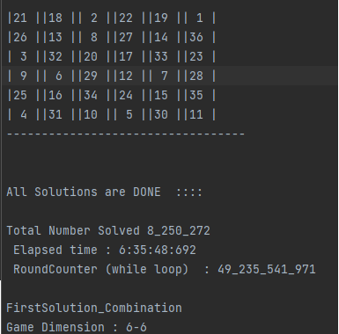

Second algorithm:

A basic math function is created for this algorithm to predict next step. So algorithm run much faster than first solution. The least this one finds a lot of solution in 10-10.

Lets have a look to Solution result for First Solution :

5-5 :

12_400 solution was found by running 1_023_656 times in while loop in 1.3 seconds.

6-6 :

8_250_272 solution was found by running 886_969_635_ times in while loop about 14 mins seconds.

7-7 :

Actually this is not wholly completed. Just first square is calculated. And results :

468_698_008 solution was found by running 72_254_456_447 times in while loop about 21 hours 19 mins seconds.  
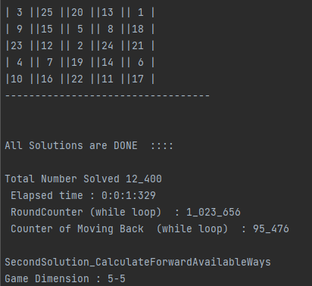 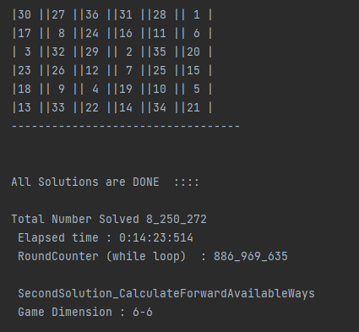

Comparing these algorithm

